**Statistics Exercise**

1.

Researchers are interested in estimating the proportion of full-time female graduate students at a university that have a job outside of the university. Surveys are sent out to all full-time female graduate students, and 67 surveys are completed and returned. Of these 67 students, 19 have jobs outside of the university. (a) What is the population of interest? (b) What is the sample? (c) What is the parameter of interest? (d) What is the statistic that estimates this parameter? (e) Is this a simple random sample? (f) Will this sample be representative of the population as a whole?

2.

Which of the following statements are true? (a) The standard deviation is always greater than the median. (b) The variance is always greater than the standard deviation. (c) If a distribution is skewed to the left, then the mean will always be less than the standard deviation. (d) If all values in a sample are within 2.0 of each other, then the standard deviation will be less than 2.0. (e) The median can equal the third quartile (Q3).

3.

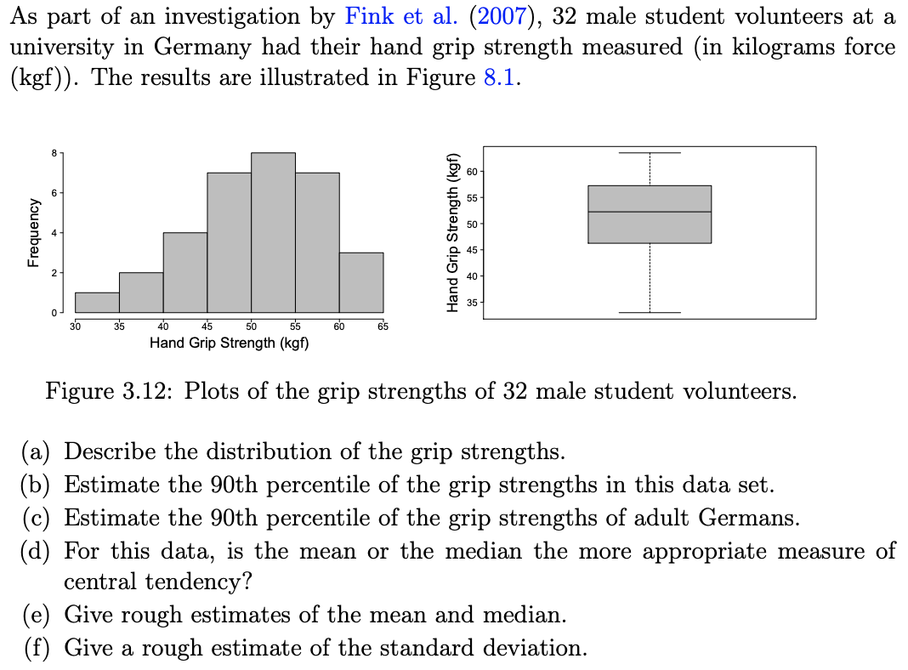

4.

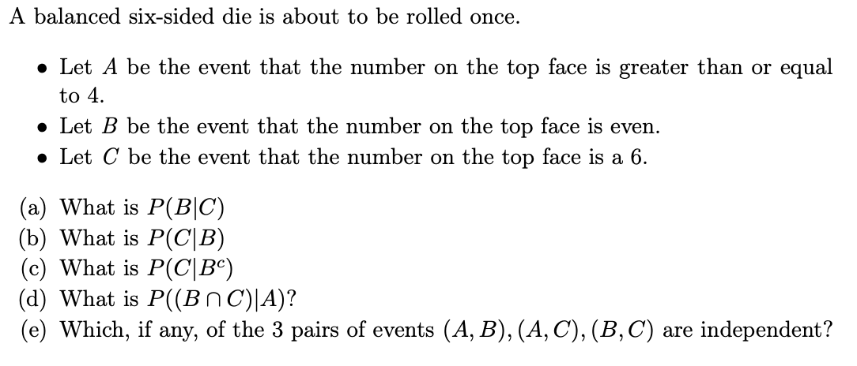

5.

Cards are drawn without replacement from a well shuffled deck. (a) If two cards are drawn, what is the probability that both cards are hearts? (b) If two cards are drawn, what is the probability both cards are fives? (c) If four cards are drawn, what is the probability of all four cards are hearts?

6.

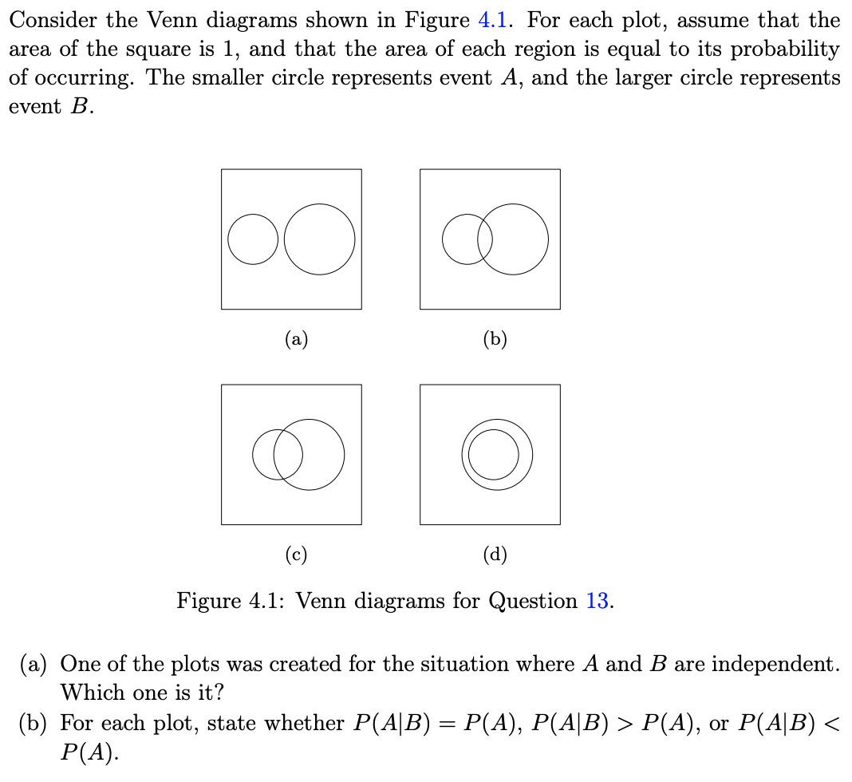

7.

An airport security official tests an experimental electronic sniffing device that can detect explosive materials. All passengers are scanned by this device, which sounds an alarm if it detects explosive material. The device is not perfectly reliable. It will falsely sound an alarm 2% of the time if the person being scanned is not carrying explosive material It will also fail to sound an alarm 8% of the time if the person being scanned is carrying explosive material. Assume that 1 in 10,000 passengers carries explosive material. If the device scans a randomly selected passenger: (a) What is the probability the alarm sounds? (b) If the alarm sounds, what is the probability the person is actually carrying explosive material?

8.

Suppose that for a certain population, the standard deviation is known but the mean is unknown. A researcher draws a random sample of 600 observations from this population, and finds a sample mean of 2200. They carry out a Z test of the null hypothesis that the population mean is 1000 against the alternative that it is greater than 1000, and find that the p-value is 0.08. Of the following options, which one best describes the meaning of this p-value? (a) If the null hypothesis is true, the probability of obtaining a sample mean at least as large as 2200 is 0.08. (b) If the null hypothesis is false, the probability of obtaining a sample mean at least as large as 2200 is 0.08. (c) The probability that the population mean is greater than 1000 is 0.08. (d) The probability that the null hypothesis is false is 0.08. (e) The probability that the null hypothesis is true is 0.08.

9.

A 2015 National Vital Statistics Report showed that in 2013, the weights of all full-term newborn babies in the United States had a mean of 3.35 kg. Does the mean weight of Hispanic newborns in the U.S. differ from this? A random sample of 100 Hispanic newborns in 2013 had a mean of 3.318 kg. Suppose the standard deviation of birth weights in the Hispanic population of the United States is known to be σ = 0.47 kg. (This standard deviation is based on sample data, but it is very close to the true value. For the purposes of this question, assume this is the correct value of the population standard deviation.) Test the null hypothesis that the mean weight of full-term Hispanic newborns in the U.S. in 2013 is the same as that of the general population (3.35 kg). (a) Give the appropriate hypotheses in words and symbols. (b) What is the value of the appropriate test statistic? (c) What is the p-value of the test? (d) Is the null hypothesis rejected at the α = 0.05 level of significance? (e) Give an appropriate conclusion to the hypothesis test.